Ideation Phase
Empathize & Discover

Date | 18 February 2026
Team ID | LTVIP2026TMIDS65684
Project Name | TransLingua – AI-Powered Multi-Language Translator
Maximum Marks | 4 Marks

Empathy Map Canvas
An Empathy Map Canvas is a visual tool used to understand users by analyzing their behaviors, thoughts, feelings, challenges, and needs. It helps the team view the problem from the customer’s perspective and design a user-centered solution.
For the TransLingua project, the empathy map focuses on users who experience communication challenges due to language barriers in education, business, travel, and research.
Understanding the user’s emotional and practical difficulties enables the development of a simple, fast, and reliable AI-powered translation system.

Target Users
- Students
- Business professionals
- Travelers
- Researchers

Empathy Map Analysis

Think
- I need to understand this content quickly.
- The translation must be accurate.
- I want a simple tool without complications.

Feel
- Confused when reading unfamiliar language.
- Frustrated when translation tools give wrong results.
- Relieved when translation is accurate and fast.

Say
- “I can’t understand this language.”
- “I need quick translation.”
- “This tool should be easy to use.”

Do
- Searches online for translation tools.
- Copies and pastes text into multiple applications.
- Compares results from different translators.

Pain Points
- Language barriers slow down communication.
- Manual translation takes time.
- Some tools are complex or require installation.

Gains (User Needs)
- Accurate AI-powered translation.
- Fast response time.
- Easy-to-use web interface.
- Secure and reliable system.

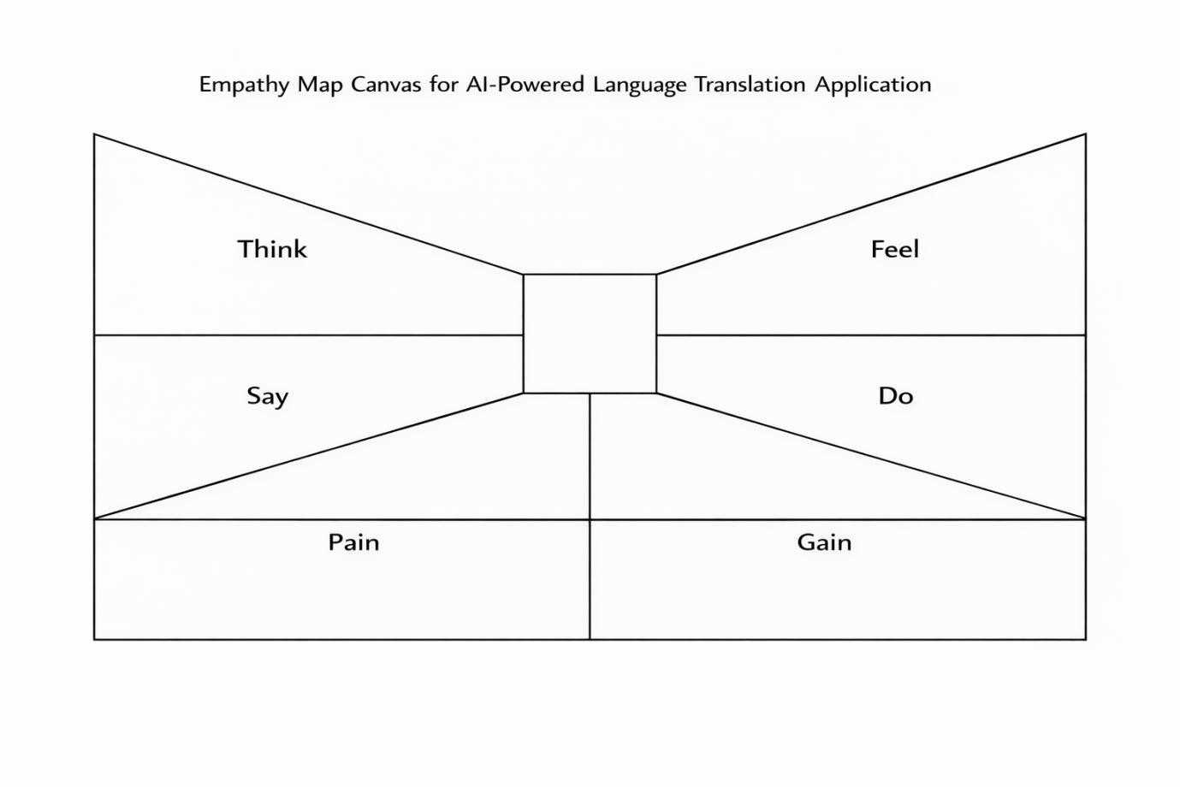

Conclusion
By understanding the user’s thoughts, feelings, challenges, and expectations, the TransLingua project is designed to provide a practical and user-centered solution using Generative AI technology.

